**System Requirements Statement (SRS) –**

**Tour Packers**

Doc. Ref. : SRS_v0.4.doc

Version : 0.4

Status : Drafted

Created by : Project Group 24

Date : 01-03-2022

1. Introduction 3

2. Functional Requirements 4

2.1 Customer Module 5

2.2 admin Module 11

2.3 message acknoeledgement Module 14

2.4 Use Case Diagram.............................................................................................................................15

THIS DOCUMENT CONTAINS 16 NUMBERED PAGES

# Introduction

This document explains the system requirements and scope for developing Tour Packer System.

Tour Packers System could divide the six main parts, Customer part, Package part, Admin part, Booking part, Payment part and the acknowledgement part.

# Functional Requirements

The Account part of Tour Packers System has six modules which are divided 13 processes described as below.

|  |  |  |
| --- | --- | --- |
| **No** | **BRS requirement ID** | **Description** |
| **2.1** | **Customer Module** | |
| **2.1.1** | **F1** | **Account Creation Process** |
| **2.1.2** | **F2** | **Login Process** |
| **2.1.3** | **F3** | **Forgot Password Process** |
| **2.1.4** | **F4** | **Change Password Process** |
| **2.1.5** | **F5** | **Update Account Process** |
| **2.1.6** | **F6** | **Package Selection Process** |
| **2.1.7** | **F7** | **Booking Process** |
| **2.1.8** | **F8** | **Payment Process** |
| **2.2 Admin Module** | | |
| **2.2.1** | **F9** | **Login Process** |
| **2.2.2** | **F10** | **Change Password Process** |
| **2.2.3** | **F11** | **Account Management** |
| **2.2.4** | **F12** | **Package Related Process** |
| **2.2.5** | **F13** | **Booking Handling Process** |
| **2.3 Message Acknowledgement Module** | | |
| **2.3.1** | **F14** | **Sends Messages of Acknowledgement** |

## Customer Module

* Customer is the user of system who wants to Book the Tour Packages.

* He is also able to view the pricing of different packages.

### Account Creation Process

* Tour Packers System compels to create the account before using it. So, Tour Packers System should provide the function which makes customer creates new account.
* When customer creates new account, the function demands four information described as below.

1. Login information
2. Contact Details

* The Login information

The Login information consists of some items described as below.

1. UserID
2. Password
3. First Name
4. Last Name
5. E-mail address
6. User Type
   * All items are compulsory demanded.
   * UserID

* The UserID should be unique. If the UserID correspond with not case-sensitive to other which is previously registered, the UserID should not be registered as an account.
  + Password
* The Password has constrains which makes the Password consists of more than or equal 8 and less than or equal 16 characteristics including characters described as below.

1. Numeric figure (at least one)
2. Capital alphabet (A-Z)(at least one)
3. Small alphabet (a-z)(at least one)
4. Special character (#, $, %, &, etc.) (at least one)

* The Password is masked by dummy characters. The re-entering Password is demanded.
* The Password must be encrypted in Tour Packers System.
  + User Type

The User Type falls into two categories described as below.

1. Customer
2. Administrator

* The User Type defines also two types of user; "Customer user", and "Administrator user”.
* In an Account Creation Process, the user can select Customer.
* No one could select The Administrator, because Administrator is implemented to Tour Packers System in advance.
* Contact Details
* The Contact Detail consists of some items described as below.

1. Permanent Address
2. Contact Phone No/Mobile
   * All items are compulsory demanded.
   * Permanent Address

* Permanent Address should be filled.
* But only the state should be selected from options.
* The Security Question information

The Security Question information is needed when customer lost their Password. This information consists of two items described as below.

1. Selected Question
2. Answer
   * All items are compulsory demanded.
   * Some questions which are difficult to answer for anyone else are prepared in advance.

E.g. which color do you like most?

* + A question should be selected from options by the customer, and the Answer is registered by the customer.
* Login information should be entered on one screen, and then customer information and Security Question information should be entered on another screen.

### Login Process

* Tour Packers System always compels user authentication before using itself except when a new account is successfully created.
* The user authentication demands UserID and Password. The UserID and the Password should be checked in three ways.
  + First, The UserID and the Password should be existed and correct.
* If The UserID and the Password are not equal to what the user has registered, the user authentication cannot be provided.
  + Second, the User Type linked to the UserID should be "customer".
* When the User Type is "Customer", then user can be placed on “Customer Home”.
  + Finally, UserID should be available.
* The Administrator can decide whether the UserID is available or suspended – Refer to the SRS of the Admin part.
* If customer is rejected, user authentication is not provided for system user.
* The customer account should alive for so long as the duration decided by Admin.
* Only when the three checks are successfully completed, customer can be placed on respected page.
* The “Customer Home” provides the some items described as below.

1. A trigger to logout
2. A trigger to update Account
3. A trigger to Change Password
4. A trigger to Search Package
5. A trigger to book package
6. A trigger to payment

### Forgot Password Process

* When system user lost their Password, the recovery method should be provided by Tour Packers system.

The recovery method is described as below.

* + First, system user enters their UserID for Tour Packers System.
  + Next, Tour Packers System demands the Answer which has been registered since when the Account was created.
  + Only when the Answer is correct, customer get the new password by E-mail which also has been registered since when the Account was created.
  + The new password is automatically generated by Tour Packers System.
* Of course, the new password should consist of more than or equal 8 and less than or equal 16 characteristics including at least a numeric figure, a capital alphabet, a small alphabet, and a special character.
* As a consequence, The Customer could get the customer authentication using the new password.
  + Then, the customer had better change the new password manually.
* If the Answer is not correct, otherwise, the correct Answer is demanded for user again.
  + In that case, Of course, customer couldn’t get the new password.

### Change Password Process

* When customer wants to change their Password, the measure should be provided by Tour Packers System.
* Therefore, Tour Packers System should provide the function which is available after getting the customer authentication.
* The function demands the current password and the new password.
  + Of course, the new password should consist of more than or equal 8 and less than or equal 16 characteristics including at least a numeric figure, a capital alphabet, a small alphabet, and a special character.
  + The current password and the new password are masked by using dummy characters.
  + The new password is demanded to enter twice to avoid a typing error.
* Only when the current password is correct, customer could change their Password.
* When the current password is changed into new password, Tour Packers System compels user authentication again.

### Update Account Process

* Tour Packers System should provide the function which makes the account updated for customer.
* The information customer could update is described below.

1. Login information
2. User information
3. Security Question Information

* The Login information

The updatable items as described below.

1. First Name
2. Last Name
3. E-mail address
   * All items are compulsory demanded, but updating is optional.

* The User information

The updatable items as described below.

1. User Name
2. User Phone No
3. E-mail address
4. Permanent address
   * All items are compulsory demanded, but updating is optional.

* The Security Question information

The updatable items as described below.

1. Selected Question
2. Answer
   * All items are compulsory demanded, but updating is optional.

### Package Selection Process

* Search conditions are described as below.

1. Customer able to view packages
2. Customer can able to select desired package of his choice.

### Booking Process

* Book Package requirements are described as below.

1. Select package
2. Select no. of seats
3. Confirm booking
4. payment

### Payment Process

* After booking the package the customer can payment following contents.

1. Credit/Debit card payment
2. UPI Payment

#### Admin Module

**•** Administratorshould be responsible for following activities**,**

### Login Process

* Tour Packers System always compels user authentication before using itself except when a new account is successfully created.
* The user authentication demands UserID and Password. The UserID and the Password should be checked in three ways.
  + First, The UserID and the Password should be existed and correct.
* If The UserID and the Password are not equal to what the admin has registered, the Admin authentication cannot be provided.
  + Second, the User Type linked to the UserID should be "Admin".
* When the User Type is "Admin", user can be placed on “Admin Home”.
  + Finally, UserID should be available.
* The Administrator can decide whether the UserID is available or suspended – Refer to t
* .0he SRS of the Admin part.
* If user is rejected, user authentication is not provided for system user.
* The admin account should alive for so long as the duration decided by Admin.
* Only when the three checks are successfully completed, Admin can be placed on respected page.
* The “Admin Home” provides the some items described as below.

1. A trigger to logout
2. A trigger to update Account
3. A trigger to Change Password
4. A trigger to Search Packages
5. A trigger to add package
6. A trigger to Update package
7. A trigger to Delete Packages

### Change Password Process

* When Admin wants to change his Password, the measure should be provided by Tour Packers System.
* Therefore, Tour Packers System should provide the function which is available after getting the Admin authentication.
* The function demands the current password and the new password.
  + Of course, the new password should consist of more than or equal 8 and less than or equal 16 characteristics including at least a numeric figure, a capital alphabet, a small alphabet, and a special character.
  + The current password and the new password are masked by using dummy characters.
  + The new password is demanded to enter twice to avoid a typing error.
* Only when the current password is correct, Admin could change his Password.
* When the current password is changed into new password, Tour Packers System compels user authentication again.

#### Accounts Management

• Admin should able to manage all the accounts with following activities,

1. Enable accounts

2. Disable accounts

#### Package Related Process

* Admin should able to manage all the package related information with following activities,

1. Admin can add packages.

The added items as described below.

1.Adding information about package.

2.Information about travelling rout.

3.Information about package price.

4.Information about allocated/available seats.

2. Admin can update existing package information.

The updatable items as described below.

1.Update information about package.

2.Update Information about travelling rout.

3.Update Information about package price.

4.Update Information about allocated/available seats.

1. Admin can delete existing package.

The deleted items as described below.

1. Admin can select and delete non required packages.

#### Accounts Management

* Admin should able to manage all the booking related information with following activities

1. Admin can see information about all the booking.

2. Admin can see booked packages.

3. Admin can see booked seats.

4.Admin can verify booking confirmation.

#### 2.3 Message Acknowledgement Module

• In following conditions acknowledgement to be send

1. After completion of successful registration.
2. After every successful transaction (booking confirmation).
3. Now the messages are being sent by using email but in future we can have mobile SMS.

#### 2.4 Use Case Diagram

**Admin:**

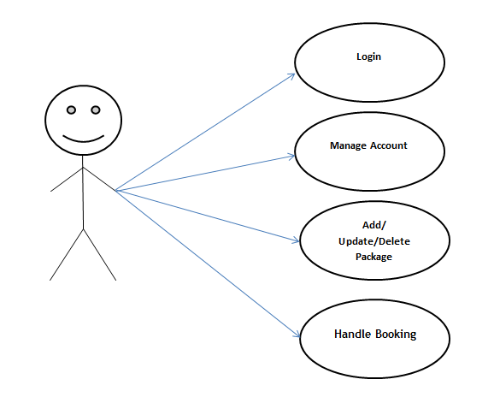

*Fig. Use case diagram for admin*

**Admin:**

1. In Admin use case diagram Admin is the Actor.
2. Admin can handle following use cases:
3. Login
4. Account Management
5. Add, Update and Delete Package
6. Booking Handling

**Customer:** 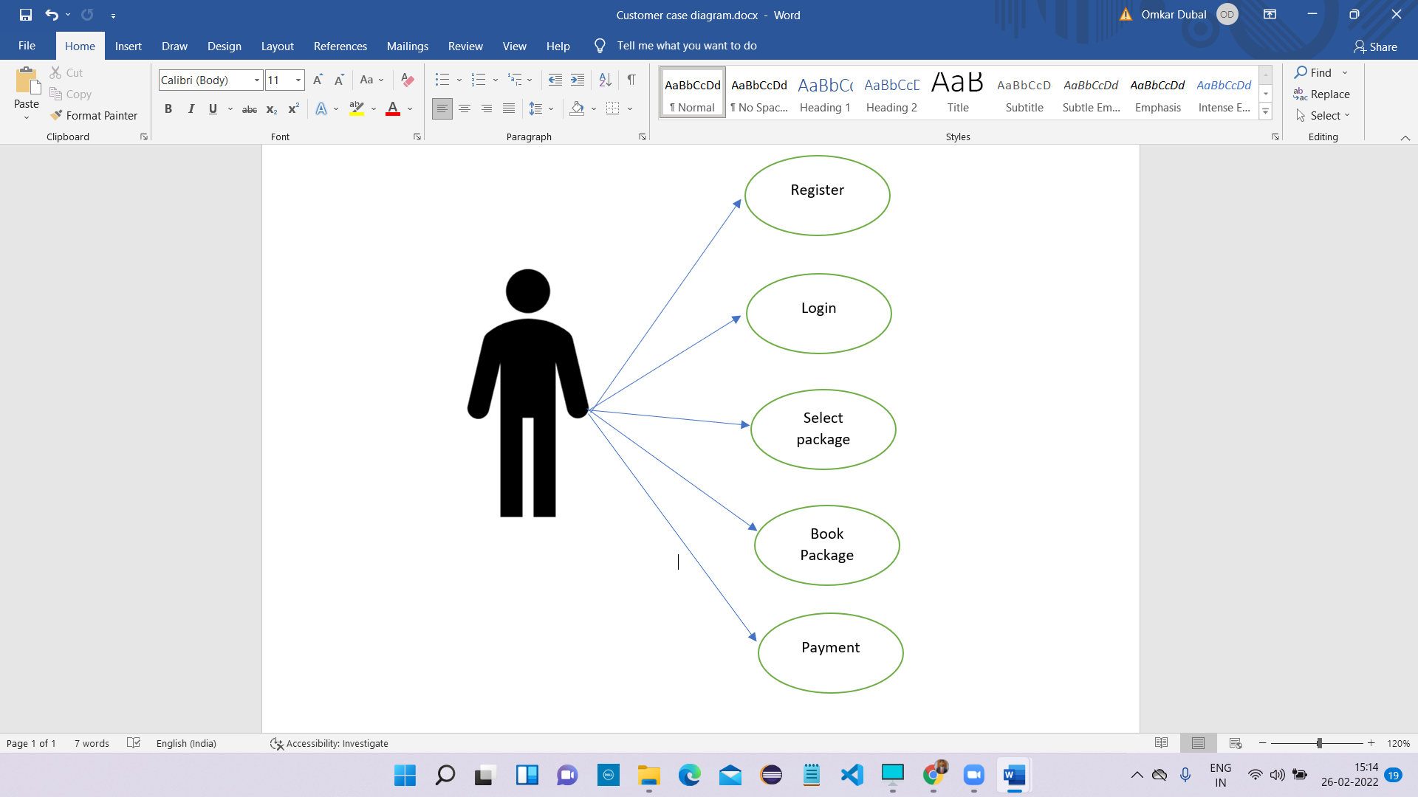

*Fig. Use case diagram for Customer*

**Customer:**

1. In Customer use case diagram Customer is the Actor.
2. Customer can handle following use cases:
3. Register
4. Login
5. Select Packages
6. Book Packages
7. Payment